Hands On Exercises - Servlets

Assignment 01 1

JSP Scripting Elements 1

Assignment 02 1

JSP Forms and Standard Actions 1

Assignment 03 2

JSP and web.xml 2

## Assignment 01

# Print current date & time - Servlet application

The most important advantage of using Servlet is that we can use all the methods available in core java. The Date class is available in java.util package.  
  
Below program shows how to print the current date and time. We can use simple Date object with toString() to print current date and time.

Configure and Deploy the app into Tomcat and check the output in the browsers.

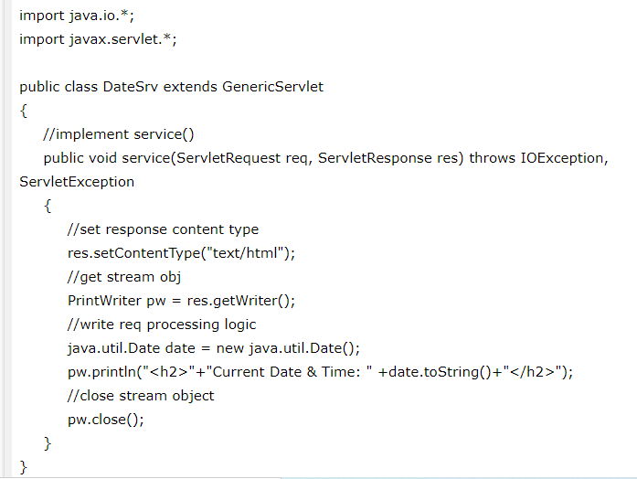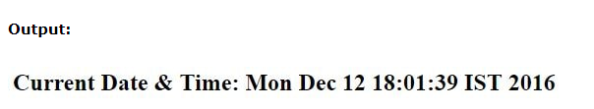

## Assignment 02

# Html & Servlet page communication using hyperlink

Configure and Deploy the app into Tomcat and check the output in the browsers.

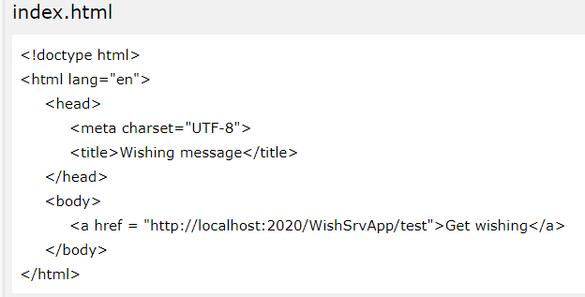

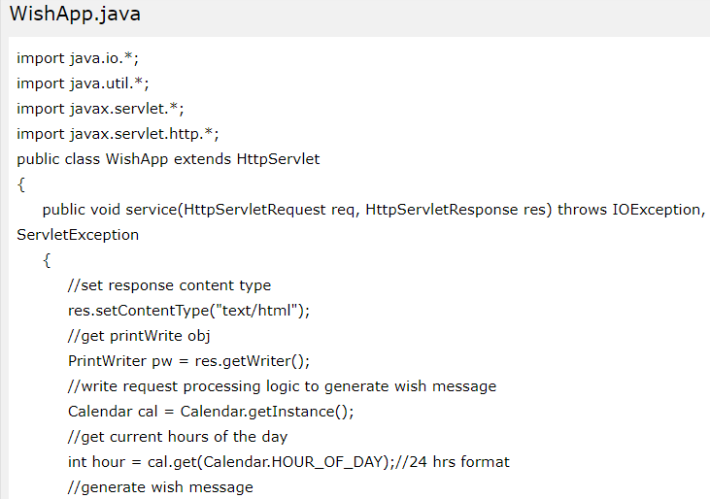

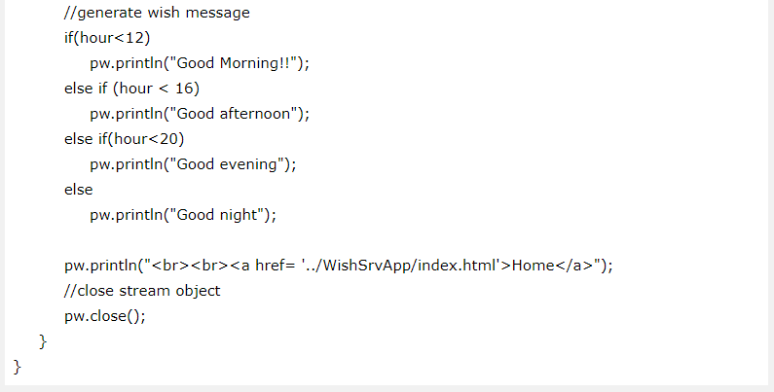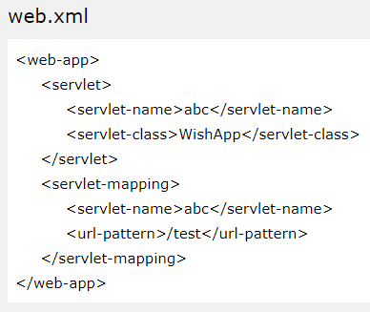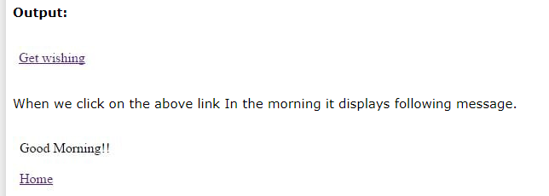

## Assignment 03

# Servlet application to auto refresh a page

When we need to refresh the web page automatically after some time, then we can use Servlet **setIntHeader()** method.  This method sends back header "Refresh" to the browser along with an integer value which indicates time interval in seconds. It is used when we displaying live game score, share market status etc.  
  
Below example shows how to use of **setIntHeader()** method to set Refresh header to simulate a digital clock.

Configure and Deploy the app into Tomcat and check the output in the browsers.



